Task 1:

Algorithm for AVL tree:

Step1: create a node.
Step 2: Check if the tree is empty.
Step 3: If tree is empty, new node is root node.
Step 4: not empty, perform Binary Search Tree insertion operation and check balancing factor of the node in the tree.
Step 5: Suppose balancing factor > apply rotations on node and resume insertion from step 4.

Task 2:

Write code for AVL tree

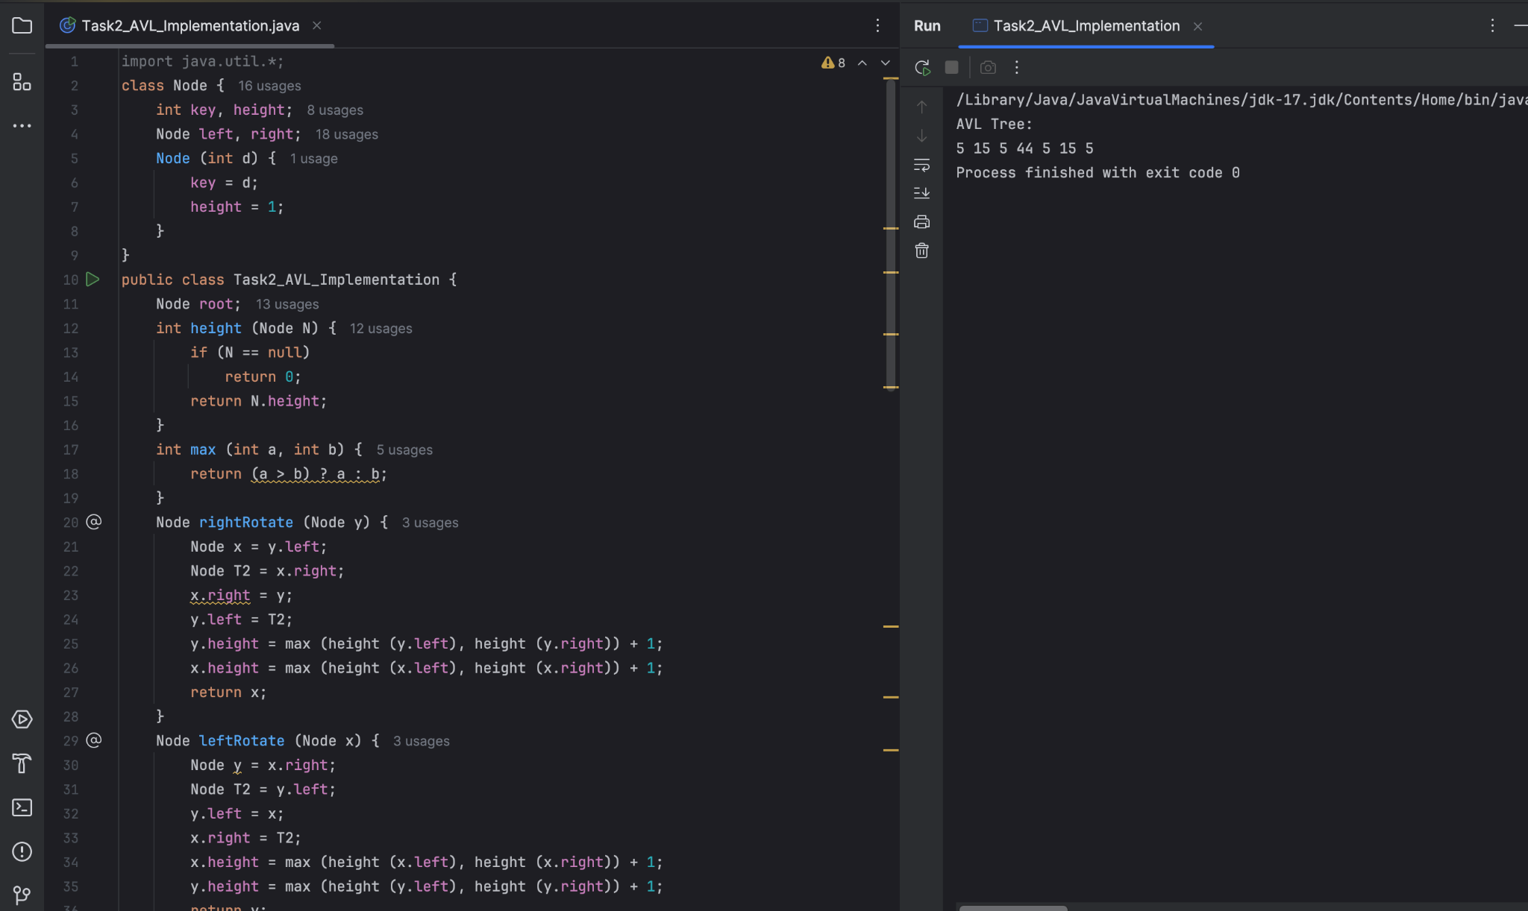

Task 3:

Algorithm for red black tree:

Insert an Element - Red Black Tree −
1. Check tree is empty. If empty, then insert new node - color Black. (Because Root Node - Black in color)
2. else if Tree - not empty then insert new node as leaf node to the end and color - Red.
3. If parent of new node is Red and its neighbours(parent’s) node is also Red,
then Flip the color of the both neighbour and Parent and Grandparents (If it is not Root Node Otherwise Flip the color of the Parent and neighbour only) i.e., Black.
4. If parent of new node is Red and its neighbours(parent’s) node is empty or NULL,
then Rotate (either Left-Left or Left-Right rotation) the new node and parent.
5. we have two types of rotation
- Left Left Rotation and
- Left Right Rotation.
6. we apply Rotation in some conditions only.
The conditions are −
- If parent of new node is Red and neighbour node is empty or NULL, then rotate left or right rotation.
- In Left-Left Rotation flip the color of the parent and grandparent.
Make the parent as Grandparent and grandparent as child.

Task 4:

Wap to insert an element in red black tree

